**DAILY ONLINE ACTIVITIES SUMMARY**

|  |  |  |  |  |  |  |  |  |
| --- | --- | --- | --- | --- | --- | --- | --- | --- |
| **Date:** | **18/5/2020** | | | | | **Name:** | **Apoorva U** | |
| **Sem & Sec** | **8th Sem** | | | | | **USN:** | **4AL16CS017** | |
| **Online Test Summary** | | | | | | | | |
| **Subject** | | **SMS: Random number generation** | | | | | | |
| **Max. Marks** | | **60** | | **Score** | | | **56** | |
| **Certification Course Summary** | | | | | | | | |
| **Course** | **DataCamp :Introduction to Python** | | | | | | | |
| **Certificate Provider** | | | **Datacamp** | | **Duration** | | | **4 hrs** |
| **Coding Challenges** | | | | | | | | |
| **Problem Statement:**  1:Using methods charAt() & length() of string class.  2:Print even and odd numbers series respectively from two threads t1 and t2. | | | | | | | | |
| **Status:COMPLETED** | | | | | | | | |
| **Uploaded the report in Github** | | | | | Yes | | | |
| **If yes Repository name** | | | | | daily_report | | | |
| **Uploaded the report in slack** | | | | | **yes** | | | |

Online Test Details: (Attach the snapshot and briefly write the report for the same)

Certification Course Details: (Attach the snapshot and briefly write the report for the same)

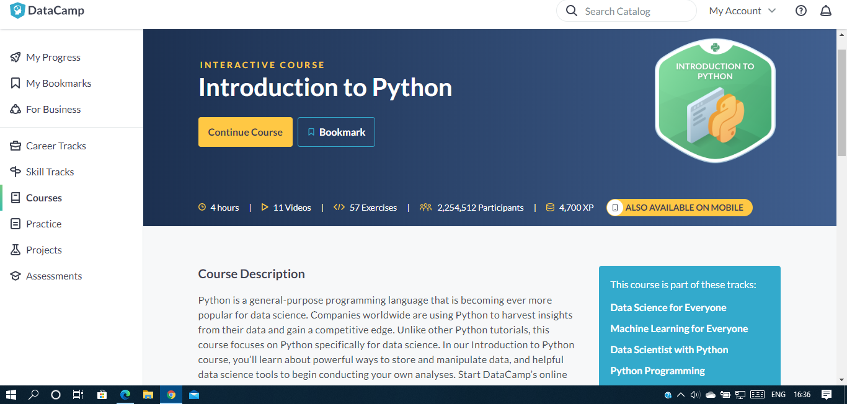

Coding Challenges Details: (Attach the snapshot and briefly write the report for the same)

Program1:

import java.util.Scanner;

public class Frequency1

{ public static void main(String args[])

{

int i;

String str;

int counter[] = new int[256];

Scanner in = new Scanner(System.in)

System.out.print("Enter a String : ");

str=in.nextLine()

for (i = 0; i < str.length(); i++)

counter[(int) str.charAt(i)]++;

}

// Print Frequency of character

for (i = 0; i < 256; i++) {

if (counter[i] != 0) {

System.out.println( (char) i + ": " + counter[i]);

}}}}

Program 2:

public class PingPong extends Thread {

static StringBuilder object = new StringBuilder("");

public static void main(String[] args) throws InterruptedException {

Thread t1 = new PingPong();

Thread t2 = new PingPong();

t1.setName("\nping");

t2.setName(" pong");

t1.start();

t2.start();

}

@override

public void run() {

working();

}

void working() {

while (true) {

synchronized (object) {

try {

System.out.print(Thread.currentThread().getName());

object.notify();

object.wait();

} catch (InterruptedException e) {

e.printStackTrace();

}

}

}

}}